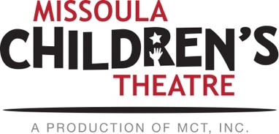

Kindred PTO, the Kindred Public Library & the Kindred Area Arts Partnership (KAAP)
are proud to present:

2021 MCT “Emperor’s New Coat”
March 22-26
@Kindred High School
KINDERGARTEN – 8TH GRADE!

*Please SIGN UP ONLINE @ SIGNUP GENIUS on the PTO, Kindred Library or KAAP websites and/or Facebook sites starting Sunday, February 7 @ 7 p.m.! Registration is first come/first serve in age brackets with a 60 student max.

You will be notified in early March with the details of the schedule and if your child made it into the show. MANY CHILDREN will make it off the waiting list and into the show, based on our junior high numbers so please utilize the waiting list option once the regular list is full.

When:
Monday, March 22 – Thursday, March 25 (auditions and practice).
3:30 -5:15 p.m. Practice
5:15-5:45 p.m. Eat (food provided)
5:45-7:30 p.m. Practice

Friday, March 26 (two performances)
**I understand my child would be released from school at 10 a.m. on Friday, March 26 for rehearsal for the performance at 1:45 p.m.
School Performance – 1:45 p.m.
Community Performance - 6:30 p.m.

Where:
Kindred High School – registered elementary students will get a “bus pass” to ride their regular bus to the high school each day after school. Parent volunteers will be waiting at the high school to help your child get off the bus and into the school.

Cost:
$30. ONLINE PAYMENT THIS YEAR. A payment link will be sent out after registration is confirmed

Questions: Jen Swenson. 701.371.5537
*****************************************************************************************************
*SIGN UP ONLINE SUNDAY, FEBRUARY 7 STARTING AT 7 P.M.- first come, first serve!

- Kindred PTO Facebook
- Kindred Area Arts Partnership Facebook or website: KindredKAAP.org
- Kindred Public Library Facebook or website KindredNDLibrary.org

